**The University of Nottingham**

**Faculty of Engineering**

**Department of Electrical and Electronic Engineering**



**EEEE3026**

**Project Outline and Planning Report**

**WellnessAI+: Elevating Mental, Emotional and Physical Health with ECG-Enhanced Artificial Intlligence**

AUTHOR : KOAY XIAN CONG

ID : 20418760

SUPERVISOR : DR HERMAWAN NUGROHO

MODERATOR : PROF T. NANDHA KUMAR

DATE : 30th OCT 2023

# Contents

1. Introduction 3

2. Problem Statement 4

3. Background Information 5

3.1. Description of Background Information 6

4. Aim and Objectives 7

4.1. Aim 8

4.2. Objectives 9

4.3. Deliverables 10

5. Proposed Methodology 11

6. Industrial Relevance 12

7. Risk and Mitigations 13

8. Project Timeline 14

9. Appendix 15

References 16

Gantt Chart 17

Project Specifications 18

# Overview of the Project

**Introduction**

The focus on this project is to incorporate electrocardiogram (ECG) and artificial intelligence (AI) driven algorithms to offer a groundbreaking approach on the edge computing to not only predict heart disease but also delve into the depths of human emotions. In this era of smart wearables, the integration of ECG with AI technology holds the potential to revolutionize the way we understand, monitor, and manage both our physical and emotional well-being. This dual-purpose capability signifies a pivotal leap forward in personalized healthcare and wellness management, ushering in a new era of preventative and predictive medicine. The deployment of AI into edge computer powered by ARM Cortex-M chip will also be further explored and discussed.

**Problem Statement**

Latterly, there has been growing acknowledgement of the significant impact that mental health has on the attainment of global development objectives, which has been illustrated by the incorporation of the Sustainable Development Goals. According to World Health Organization (WHO), depression stands out as a major contributor to disability, while suicide ranks fourth leading cause of death among individuals aged 15 to 29. [abc] Although there have been advancements made towards the mental health issue, individuals dealing with mental health issues frequently encounter serious infringements of their human rights, discrimination, and social stigma. [abc]

An electroencephalogram (EEG) is a commonly utilized tool to diagnose and measure the electrical activity in the brain. It involves the use of electrodes placed on the scalp to detect and monitor the brain’s electrical impulses and patterns of activity. The resulting data is typically displayed as a series of waveforms and is used to assess brain function, diagnose various neurological conditions, and study brain activity in research settings. EEGs are commonly employed in clinical medicine to aid in the diagnosis and management of conditions such as epilepsy, seizure disorders, emotions, stress level, etc. Since EEG is a valuable tool, there are a lot of researchers incorporating EEG as a reliable tool to detect and recognize emotion. However,

Mental health aside, cardiovascular disease (CVDs) stands as the primary global cause of mortality, claiming around 17.9 million lives annually according to WHO. [gws] More than 80% of CVD-related deaths result from heart attacks and strokes, with one-third occurring prematurely in individuals under 70 years of age. [gws] Both mental and physical health, specifically heart related issues contributed a significant

An electrocardiogram (ECG) can perform a simple test that records the electrical activity of the heart over a period. It is a widely used diagnostic tool to assess the heart’s rhythm and electrical conduction. The test is typically performed using electrodes placed on the skin’s surface at specific locations on the chest, arms, and leges. These electrodes detect the electrical signals generated by the heart as it beats and transmits the information to an ECG sensor, which then produces a visual representation of the heart’s electrical activity in the form of a graph or a series of waves. ECG can provide vital information about various aspects of cardiac health, including heart ratee, the regularity of heartbeats, signs of abnormal rhythms, and the presence of certain heart conditions, such as ischemia or structural abnormalities. [gad] Since ECG is a valuable tool used for diagnosing and monitoring heart-related issues and commonly used in medical settings, there are a wide array of studies performed on enhancing ECG with Artificial Intelligence on heart disease analysis and prediction.

Since there are physiological interrelations between the heart and brain which will be further discussed in this report, there are certain characteristics that can be detected in the pulses of the heart when it comes to emotion.

# Problem Statement

# Background Information

# Description of Background Information

# Aim and Objectives

# Aim

# Objectives

# Deliverables

# Proposed Methodology

# Industrial Relevance

# Risk and Mitigations

# Project Timeline

# Appendix

# References

[abc] <https://www.who.int/health-topics/mental-health#tab=tab_1>

[gws] <https://www.who.int/health-topics/cardiovascular-diseases#tab=tab_1>

[gad] https://litfl.com/myocardial-ischaemia-ecg-library

# Gantt Chart

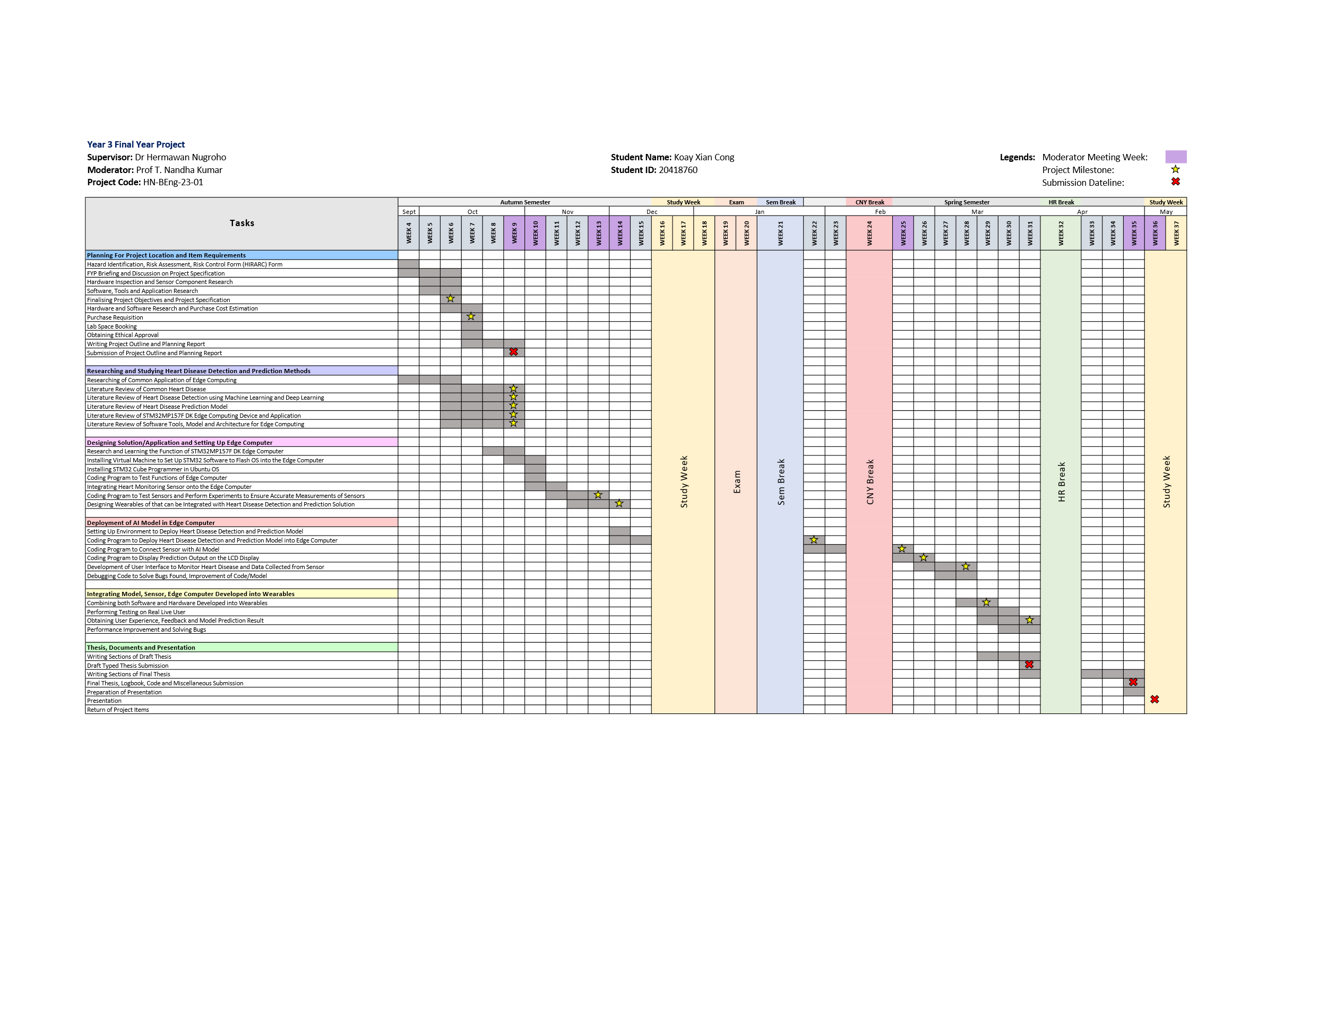

# Project Specifications

